PSP0201

Week 2

Writeup

Group Name: GLM

Members

|  |  |  |
| --- | --- | --- |
| **ID** | **Name** | **Role** |
| 1211102971 | Leong Chun Kit | Leader |
| 1211103023 | Yap Weng Hong | Member |
| 1211101232 | Lim Kai Qian | Member |
| 1211101407 | Tan Fu Shun | Member |

**Day 1: Web Exploitation – A Christmas Crisis**

**Tools used**: Kali Linux, Firefox

**Solution/walkthrough**:

Question 1

Copy and paste the machines IP into the browser search bar. Right click and click on the view page source to find out the title of the website.

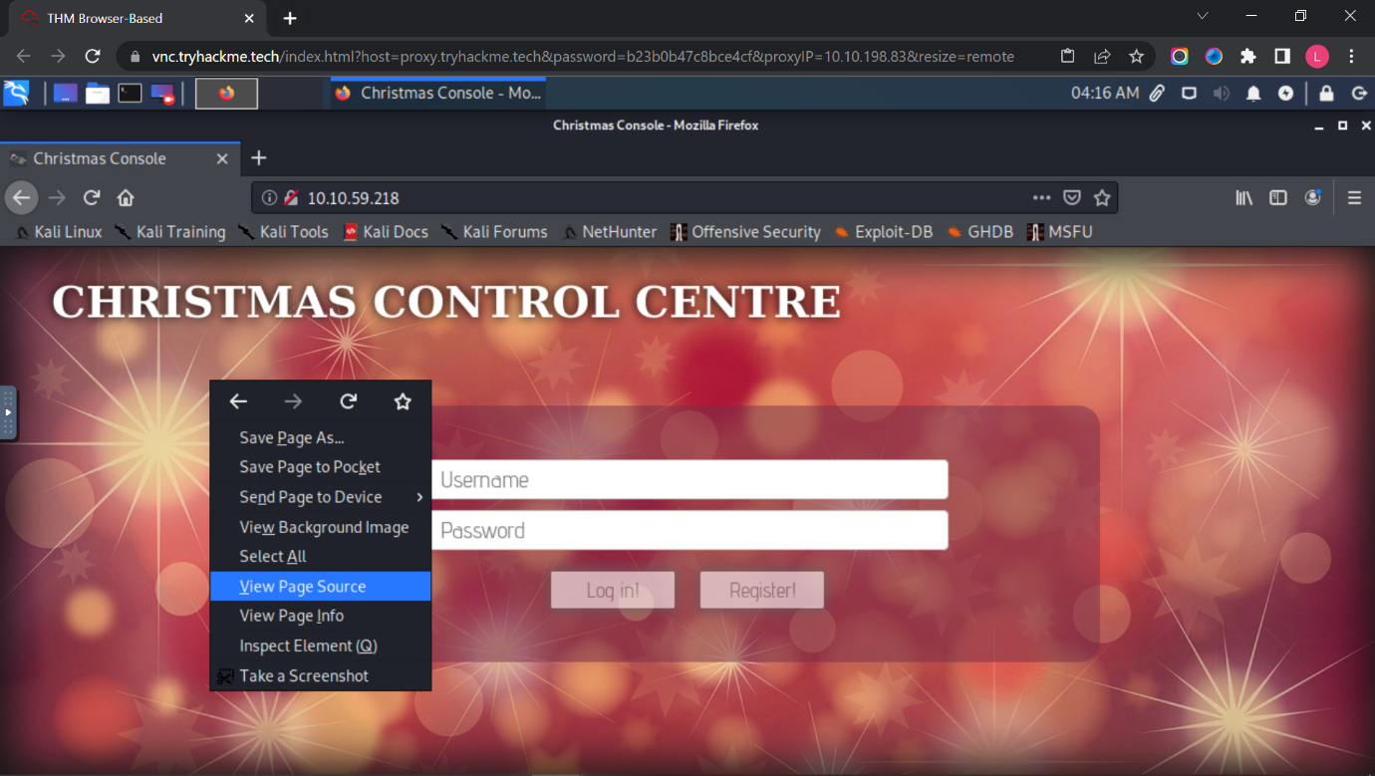

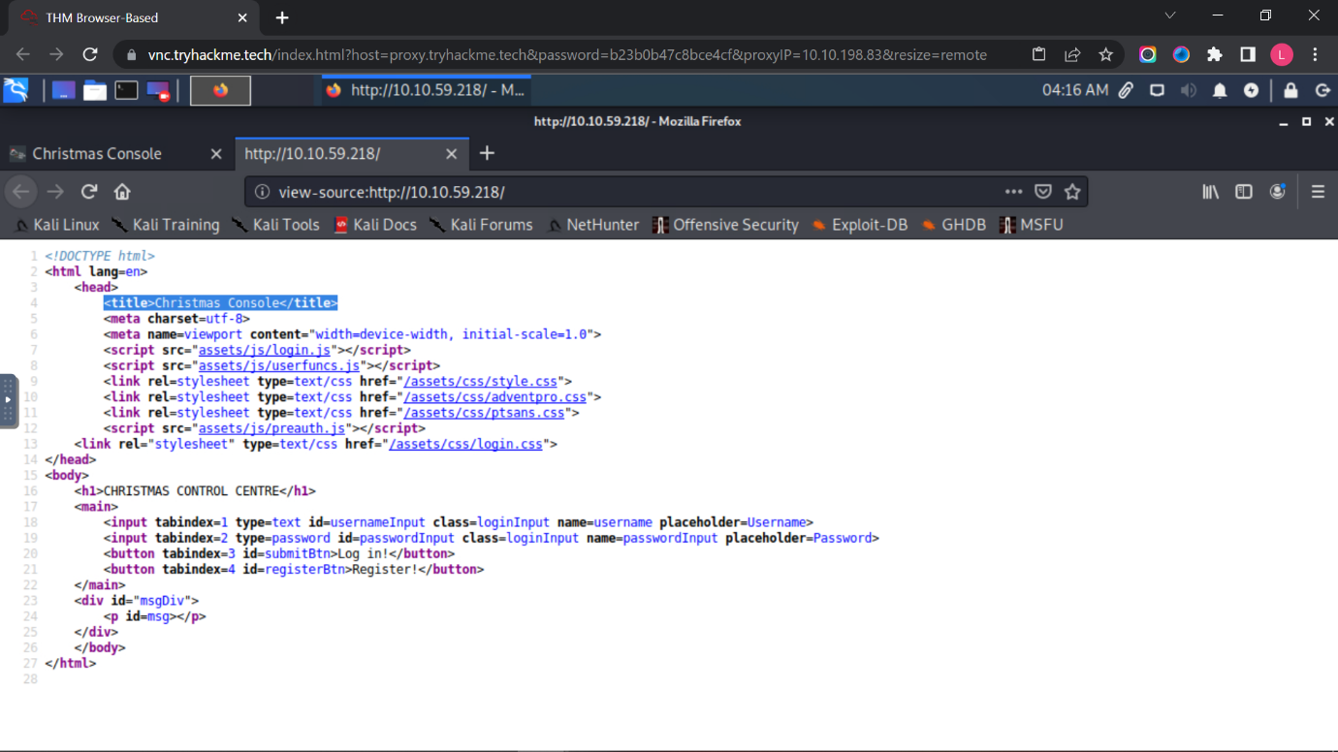

Question 2

Registration and logging in to the Christmas Control Centre. No access to the control console.

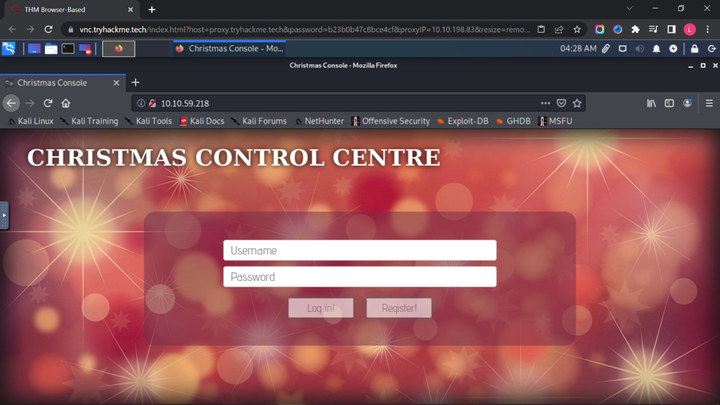

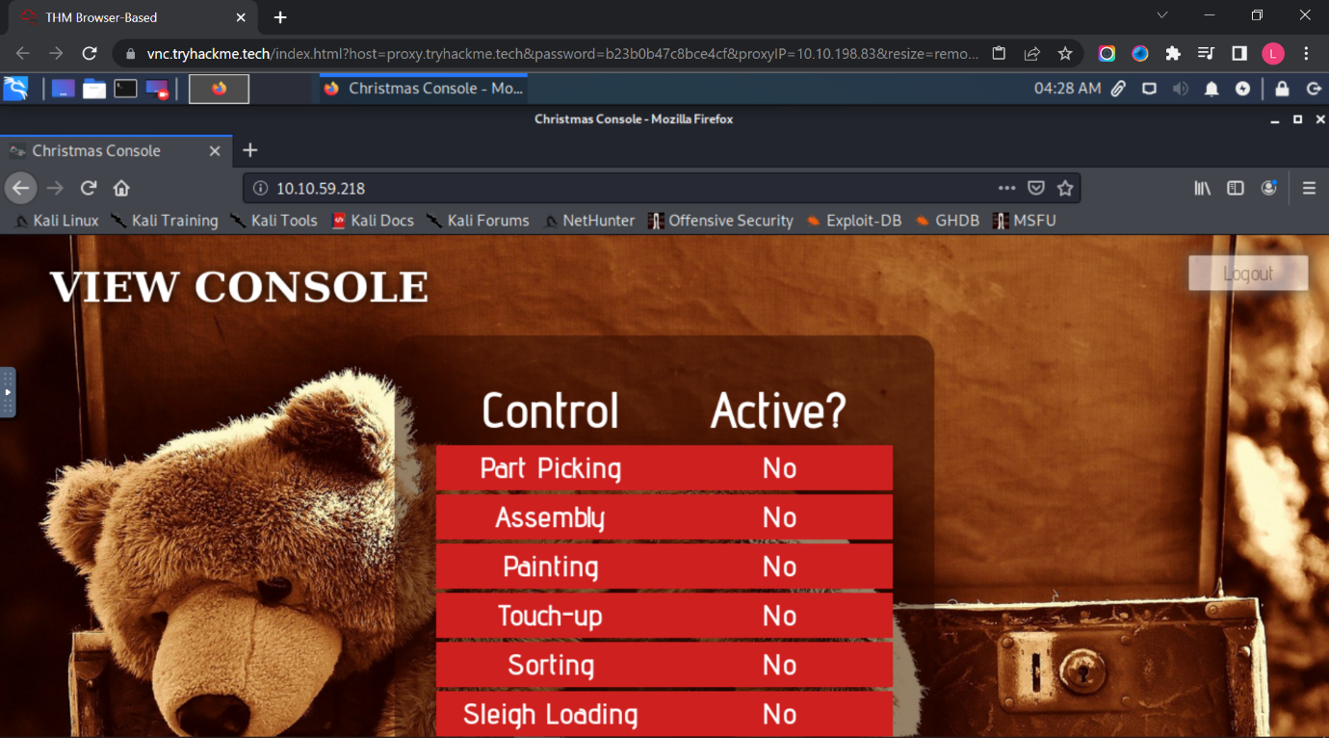

Opening up the browser developer tools to check on the cookie.

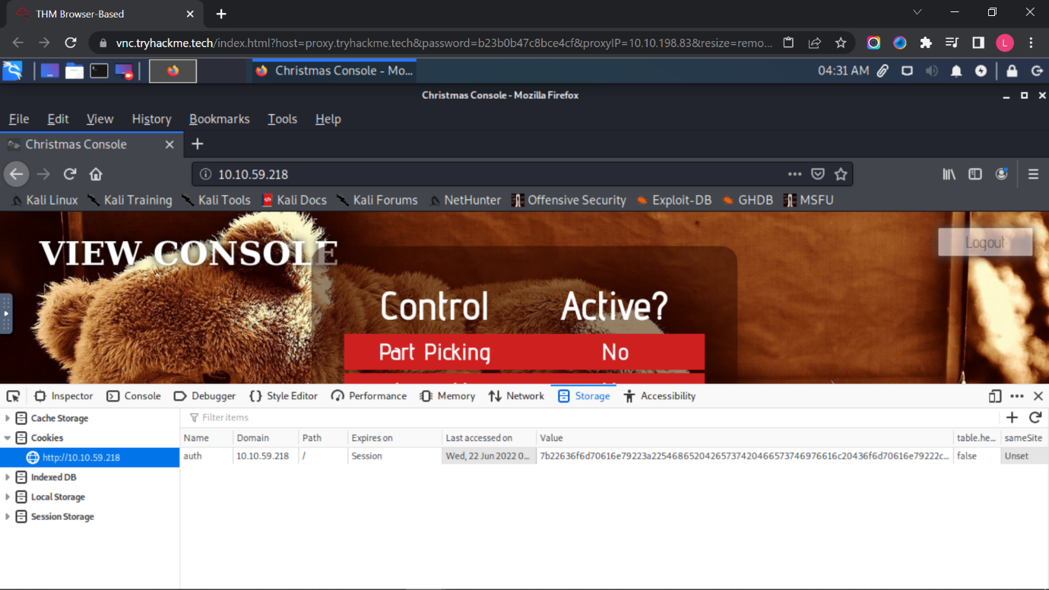

Question 3

Using Cyberchef, convert the cookie value to string.

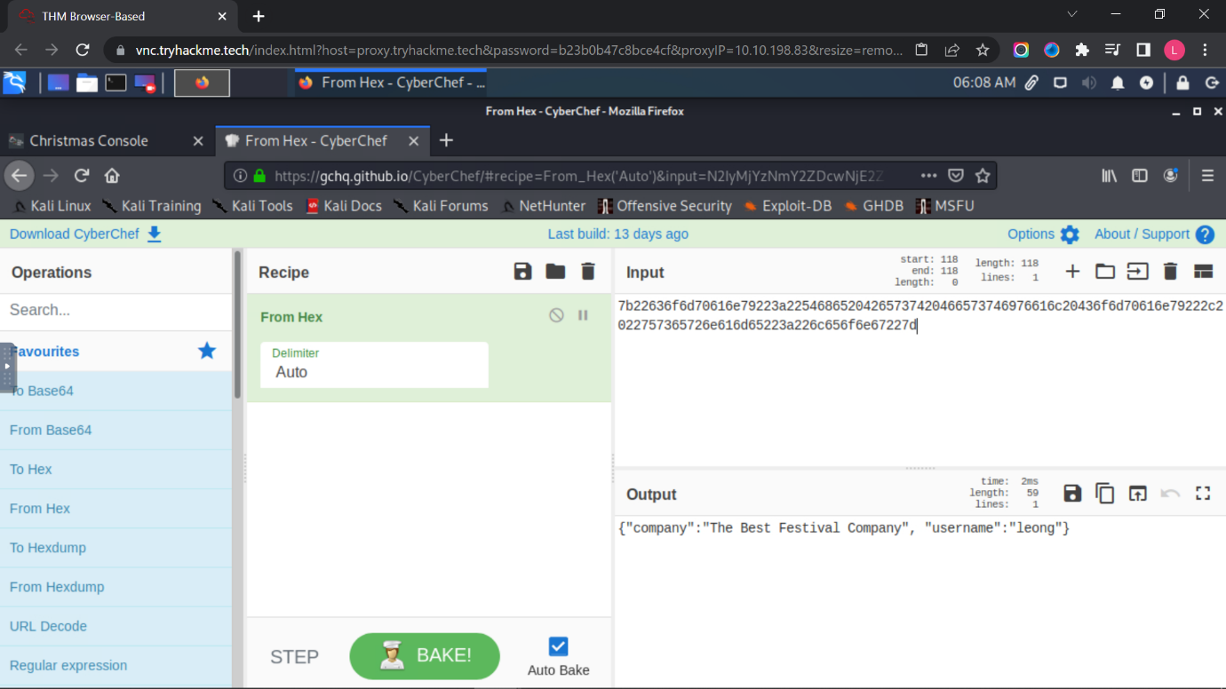

Question 4, 5, 6 and 7

Changing the username to ‘santa’, convert the JSON statement to hex.

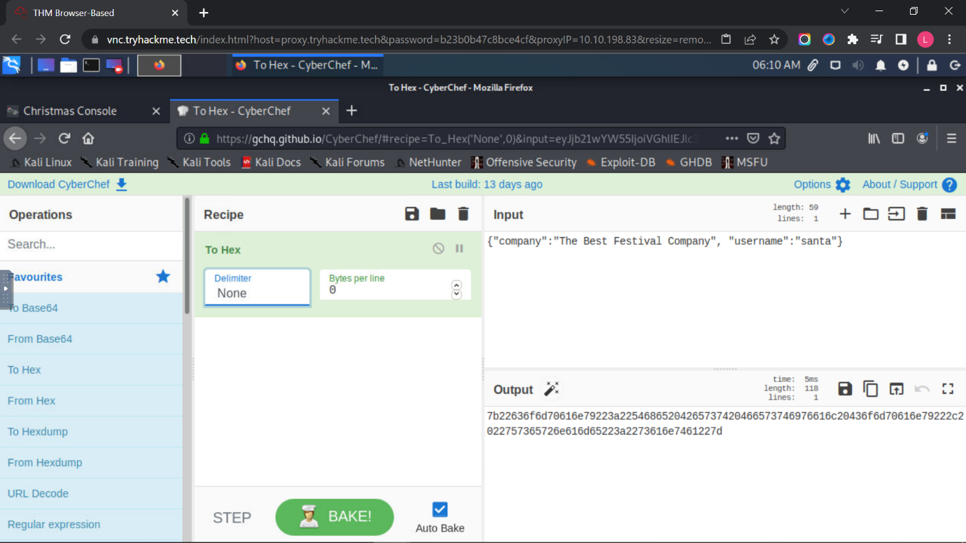

Question 8

Now having access to the controls, switching on every control shows the flag.

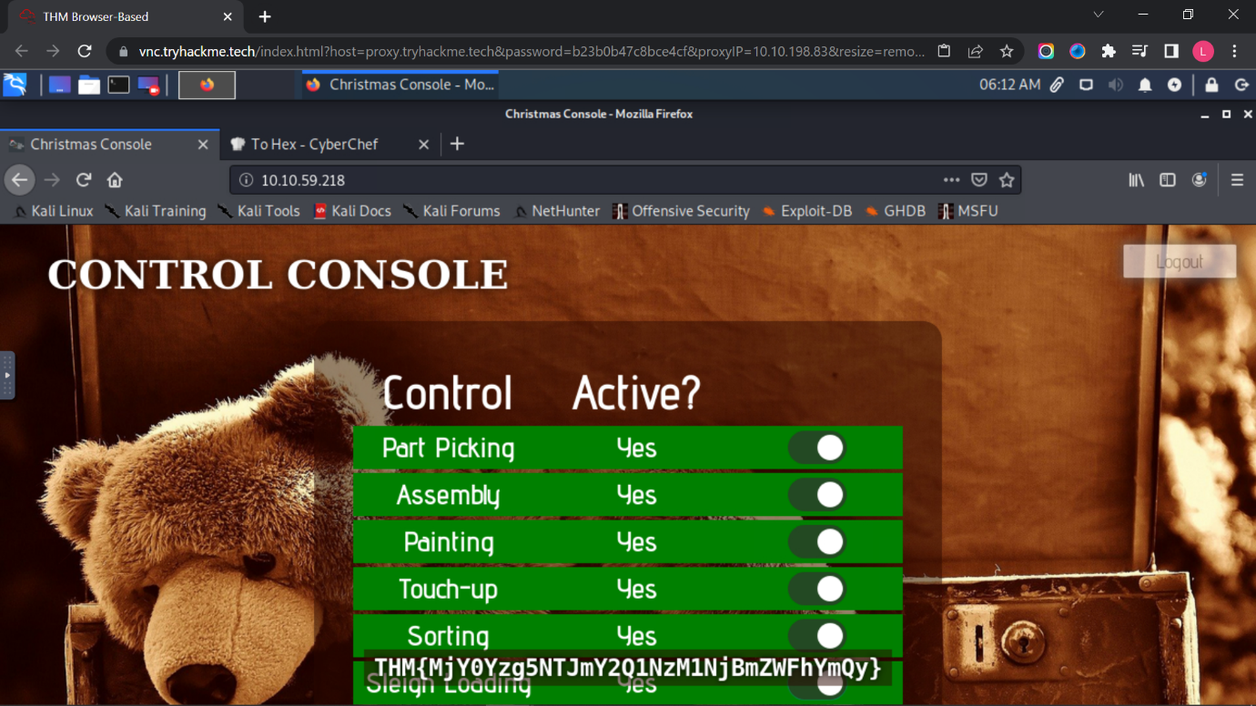

**Thought Process/Methodology:**

Having accessed the target machine, we were shown a login/registration page. We proceeded to register an account and login. After logging in, we open the browser’s developer tool and chose to view the site cookie from the Storage tab. Looking at the cookie value, we deduced it to be a hexadecimal value and proceeded to convert it to text using Cyberchef. We found a JSON statement with the username element. Using Cyberchef, we altered the username to ‘santa’, the administrator account, and converted it back to hexadecimal using Cyberchef. We replaced the cookie value with converted one and refreshed the page. We are now show an administrator page (Santa’s) and proceeded to enable every control, which in turn showed the flag.

**Day 2: Web Exploitation – The Elf Strikes Back!**

**Tools used**: Kali Linux, Firefox, Terminal

**Solution/walkthrough**:

Question 1

Copy and paste the machines IP and the string of text “?id=ODIzODI5MTNiYmYw” into the browser search bar to access this webpage.

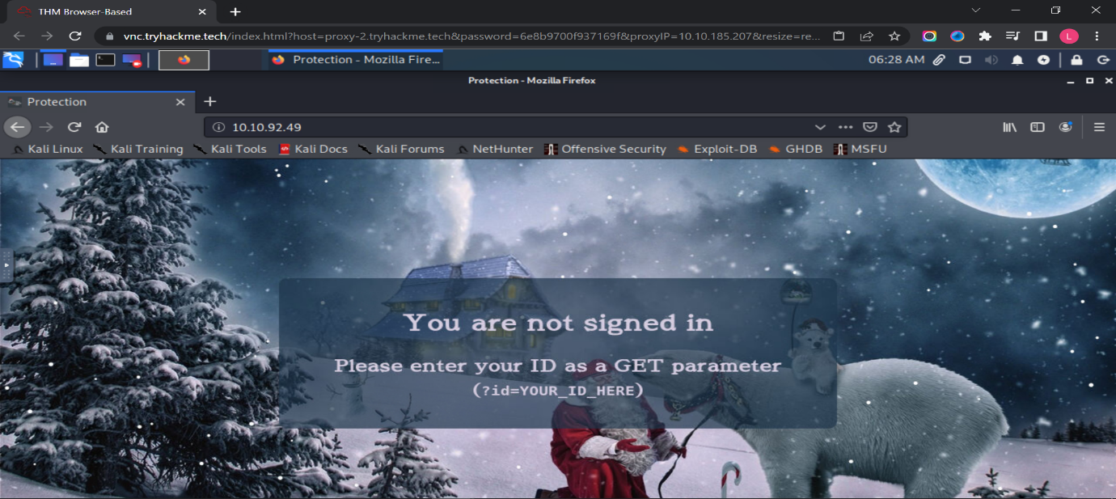

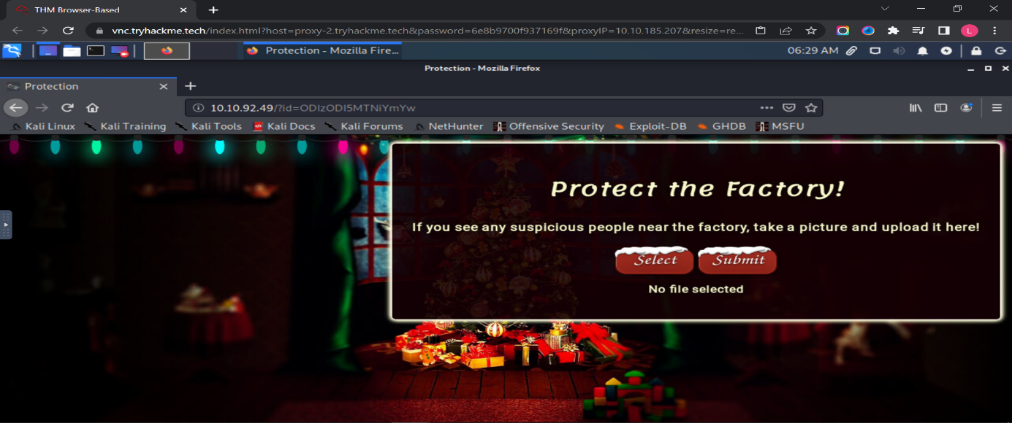

Question 2

The type of file is accepted by the site is image.

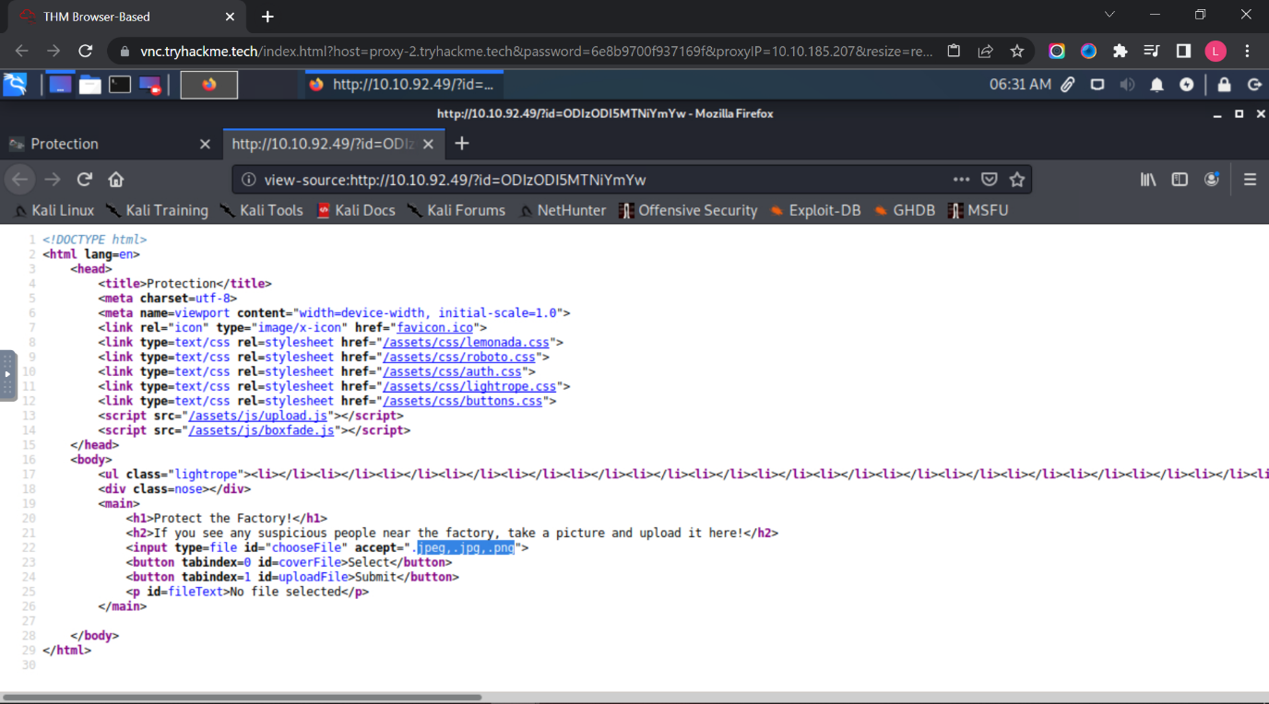

Question 3

We might able to find the uploaded script at <http://10.10.92.49/uploads/>

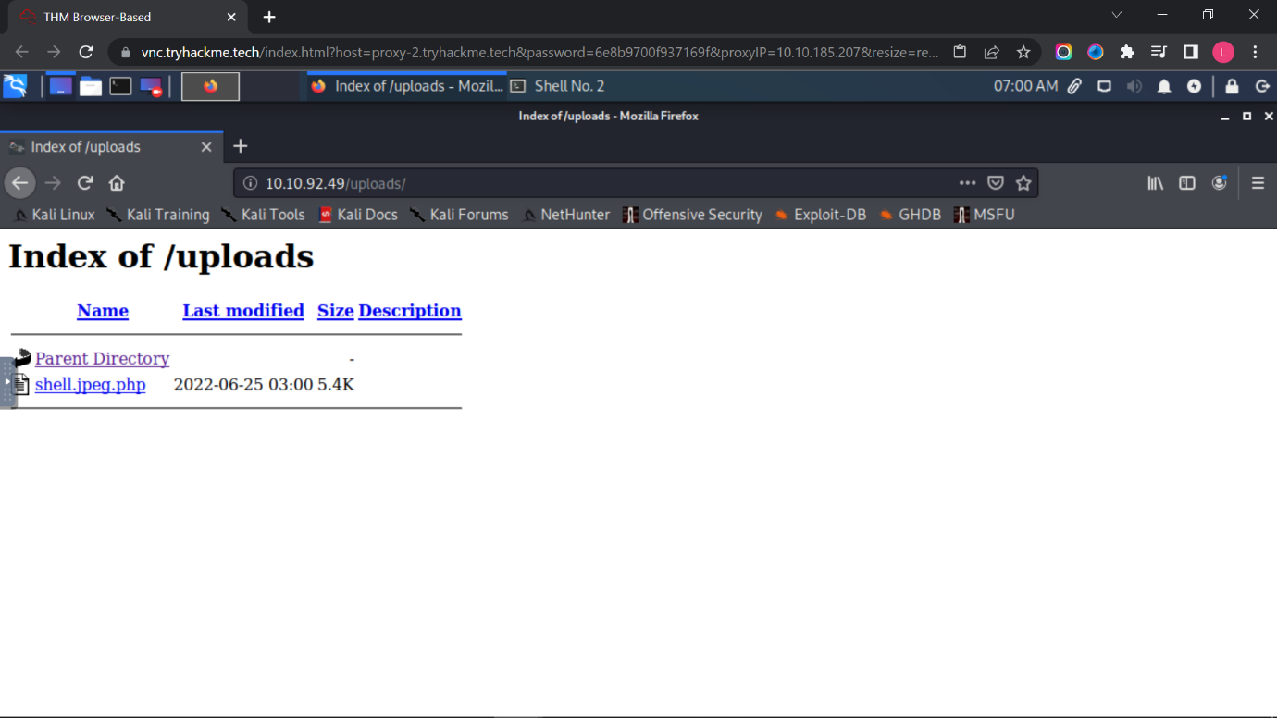

Question 4

After the shell is connected successfully, type cat /var/www/flag.txt and you will get the flag.

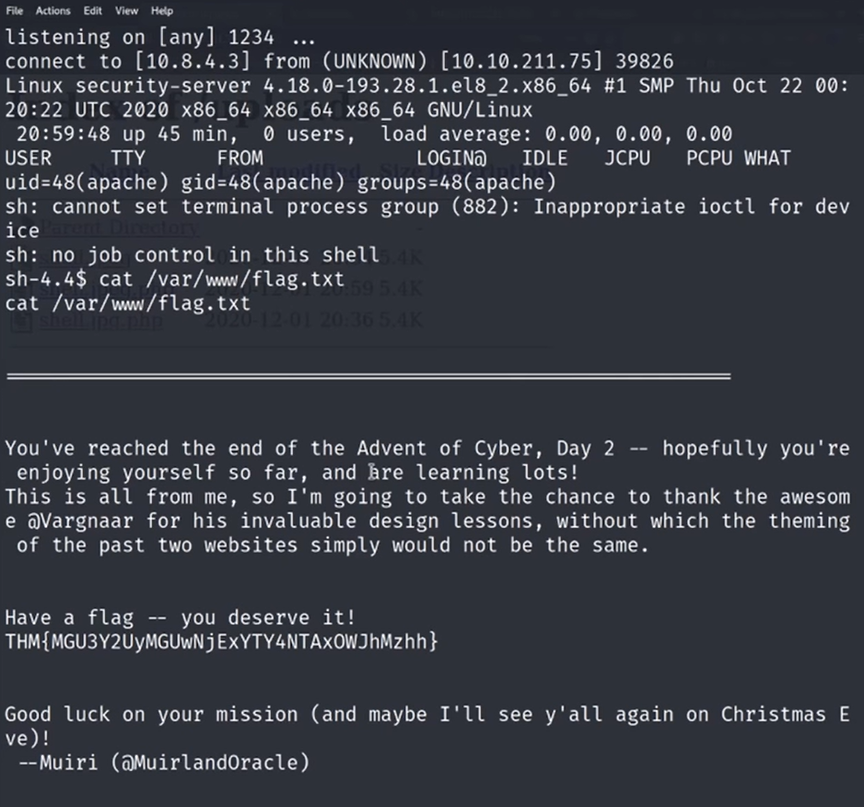

**Thought Process/Methodology:**

After copy and paste the machines IP and the string of text “?id=ODIzODI5MTNiYmYw” into the browser search bar to access the webpage. Next, we open the terminal and copy the webshell out into the current directory (cp /usr/share/webshells/php/php-reverse-shell.php .). We type nano shell.jpeg.php in the terminal and change the IP address and port then save it. Then, we open a new tab and create a listener for an upload reverse shell by using this command “nc -lvnp 443”. We select the file “shell.jpeg.php” and press submit. We access to <http://IP> address/uploads/ and found the file that we submitted. We click on the “shell.jpeg.php” and back to the terminal. Lastly, we type cat /var/www/flag.txt and get the flag from the terminal.

**Day 3: Web Exploitation – Christmas Chaos**

**Tools used**: Kali Linux, Firefox, Terminal, BurpSuite

**Solution/walkthrough**:

Question 1

The name of the botnet mentioned in the text that was reported in 2018 is call Mirai.

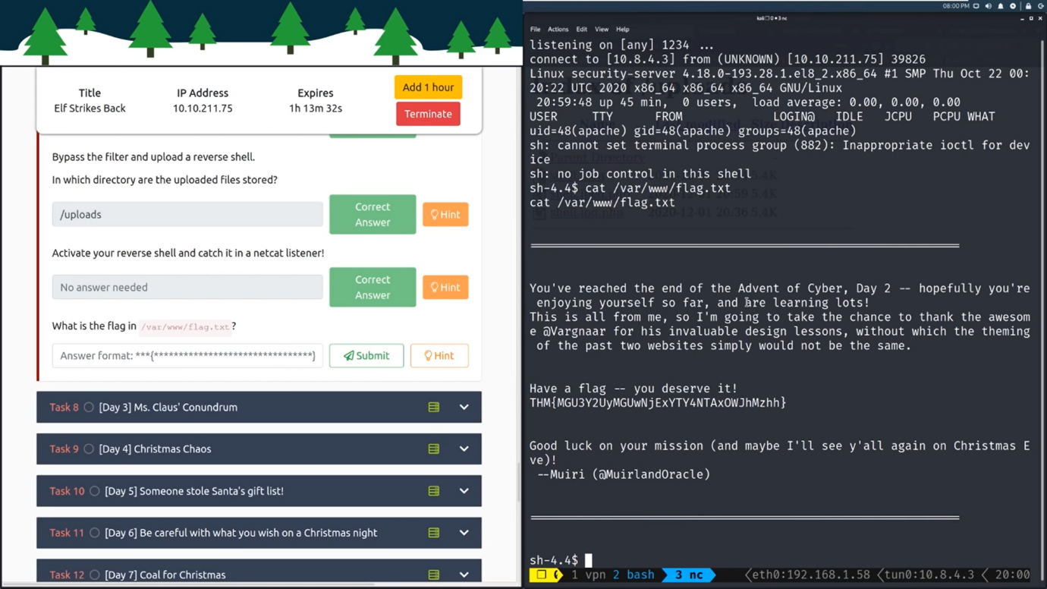

Question 2

Starbucks pay $250 for reporting default credentials.

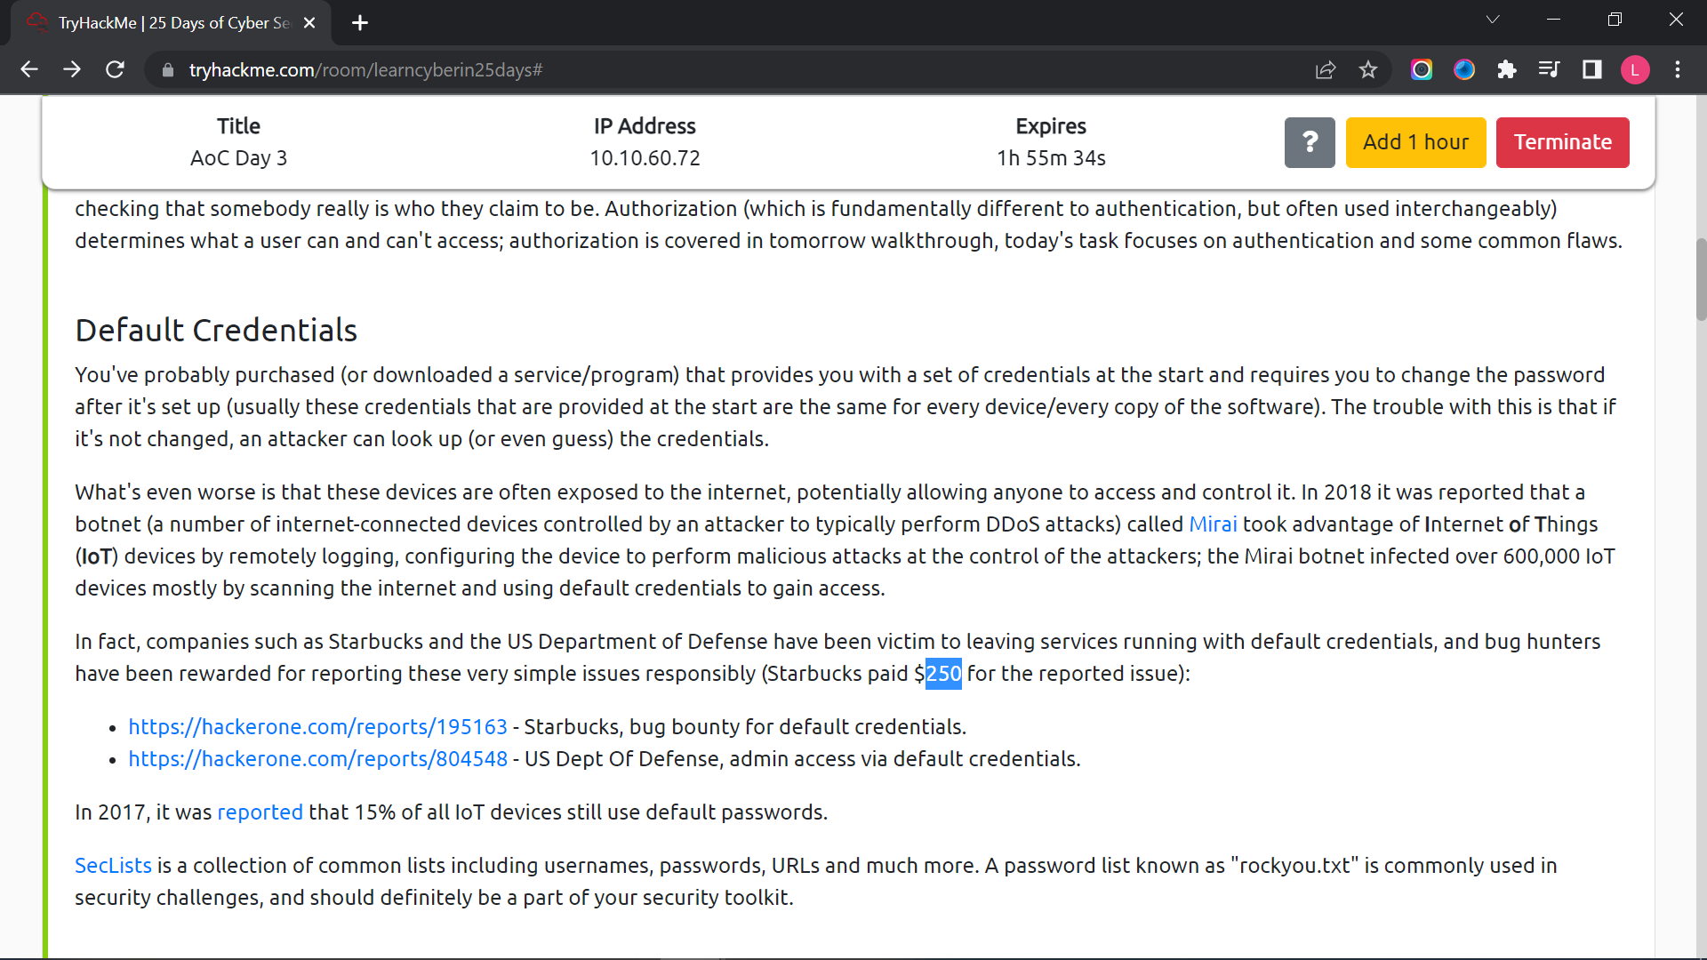

Question 3

The agent assigned from the Dept of Defense that disclosed the report on Jun 25th is agent-l8.

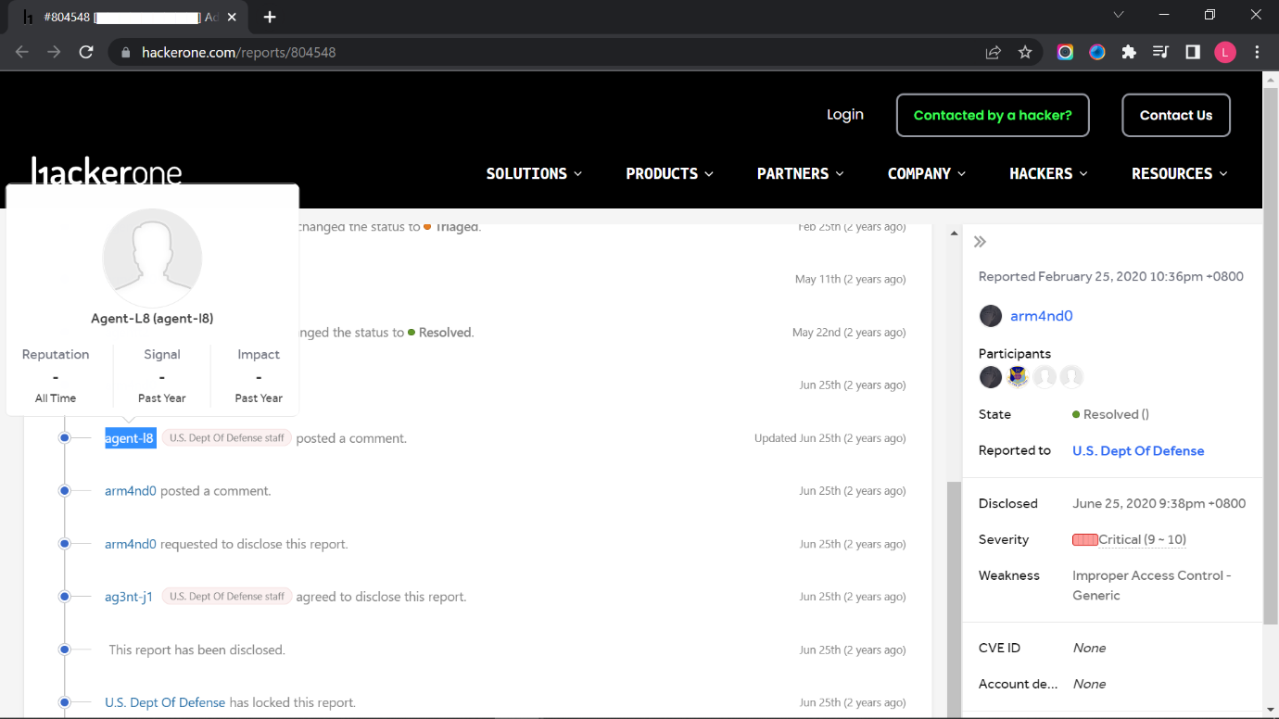

Question 4

The port number for Burp is 8080.

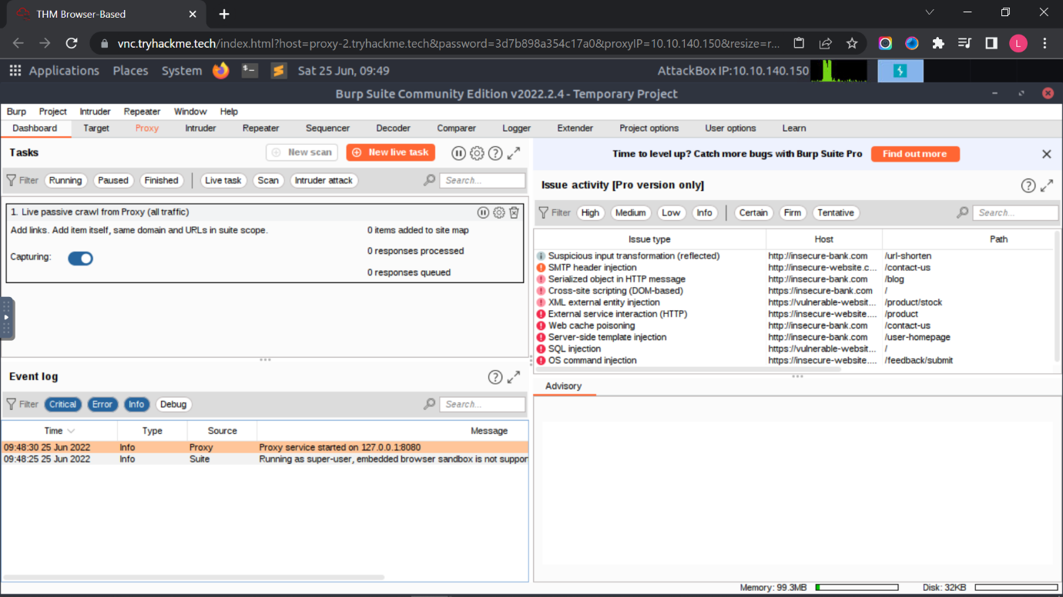

Question 5

The proxy type is HTTP

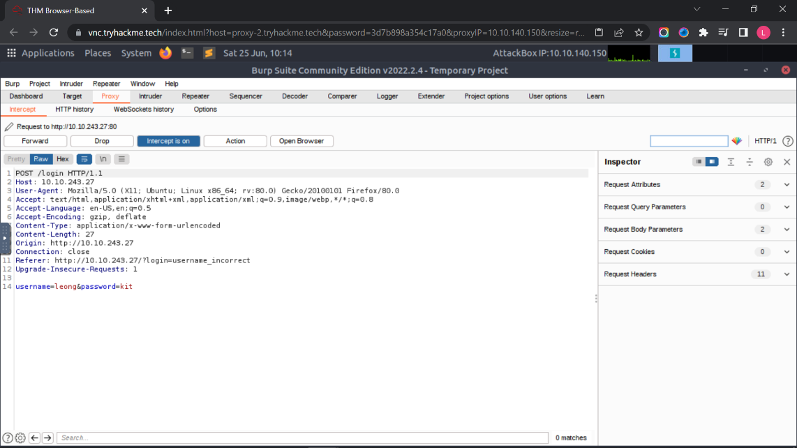

Question 6

The URL encoding for “PSP0201” is %50%53%50%30%32%30%31.

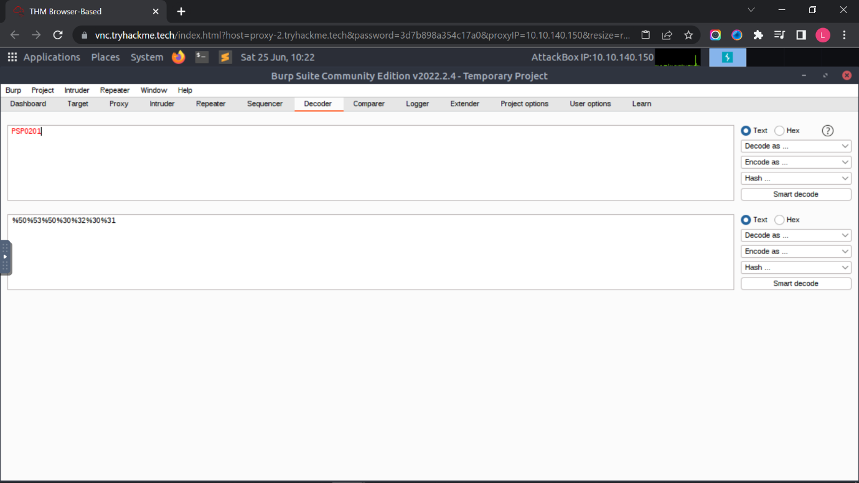

Question 7

The following options matches the one in the description is Cluster bomb.

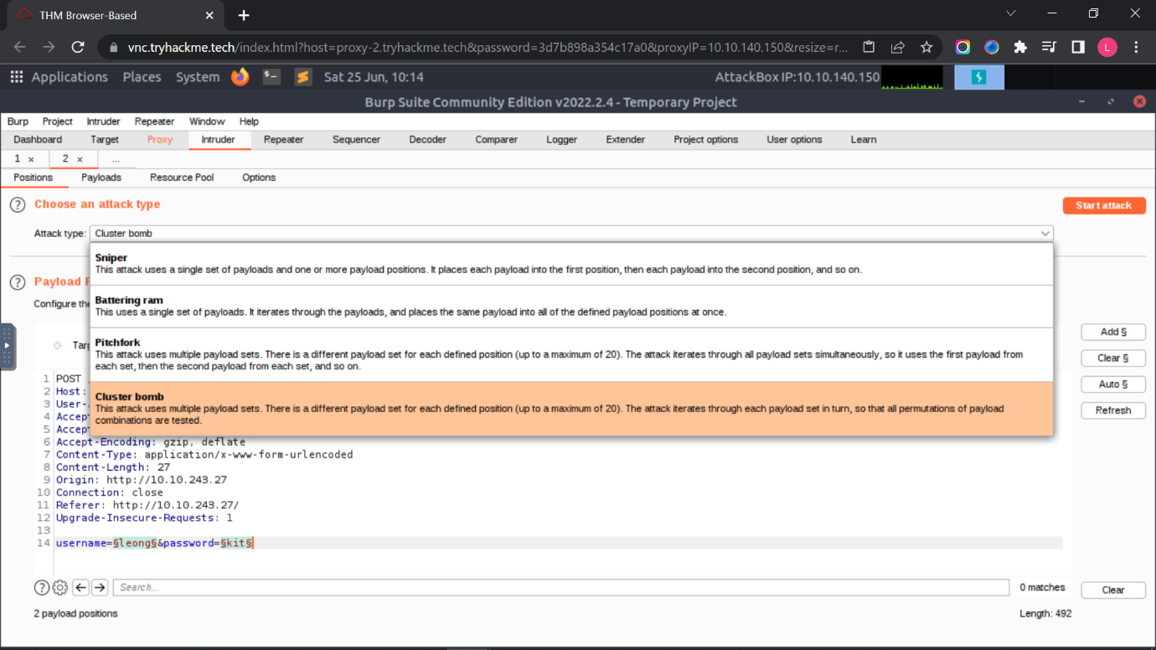

Question 8

First, we need click the “Position” tab, and clear the pre-seleted position and add the username and password values as positions. After that, we need to change the attack type to cluster bomb.

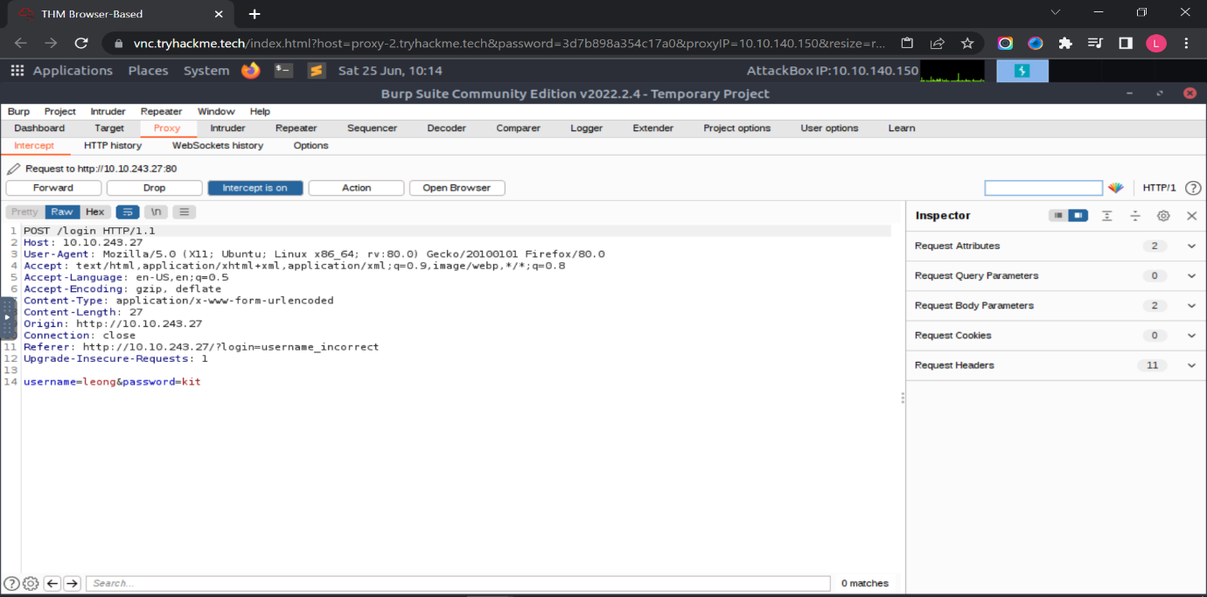



For set 1 (username), we will add a few common default username entries such as "admin", "root" and "user". For set 2 (password), we will add a few common default passwords such as "password", "admin" and "12345". Next, we click the “Start Attack” button.

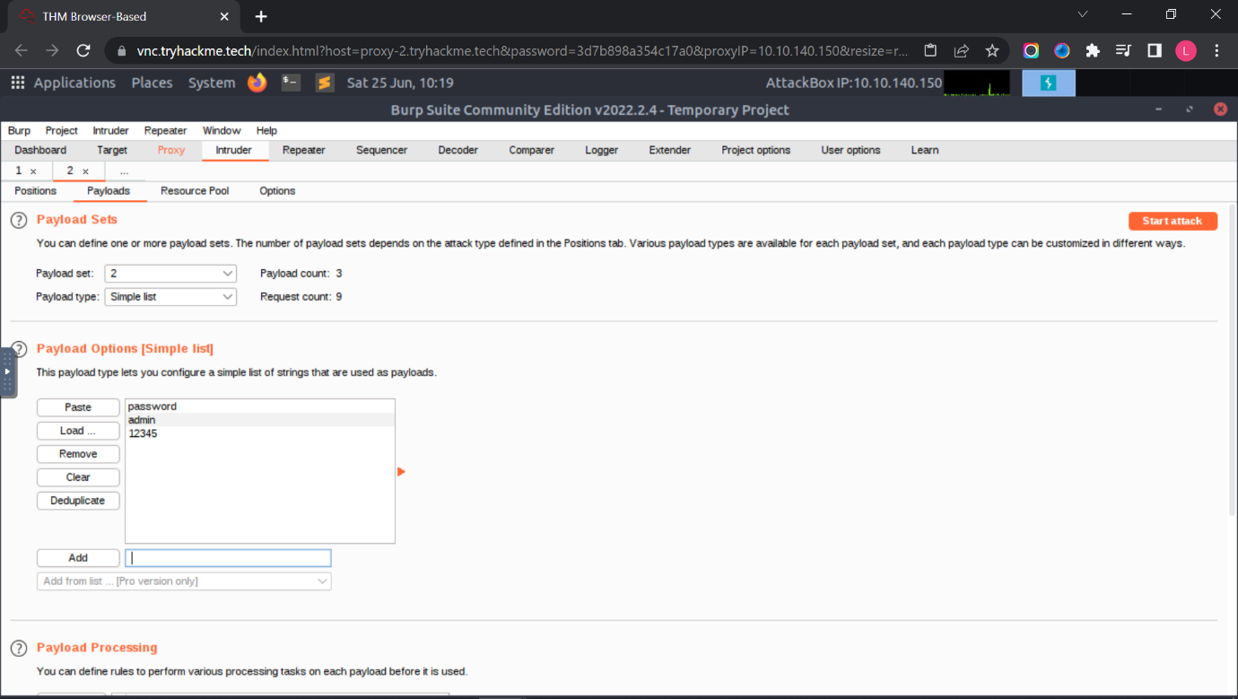

We look for the set that are different lengths from others. Next, we close the interception off and type the set that we found. Lastly, we finally find the flag.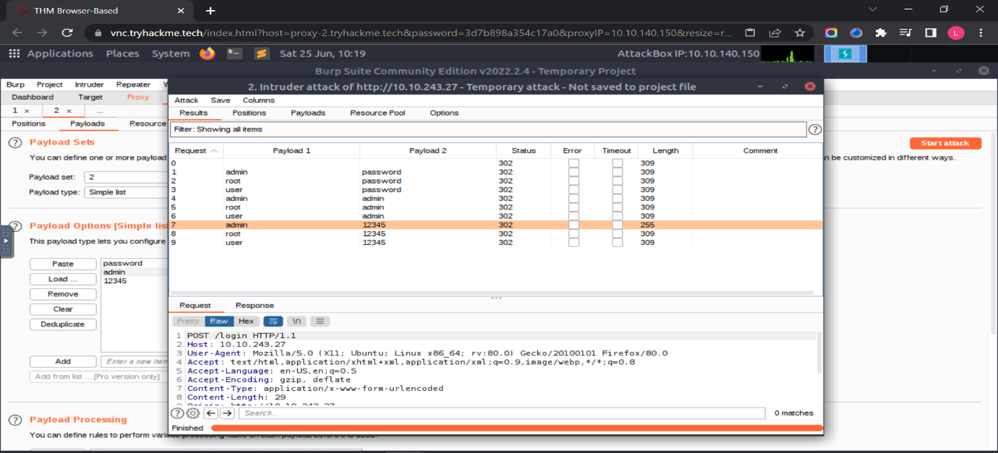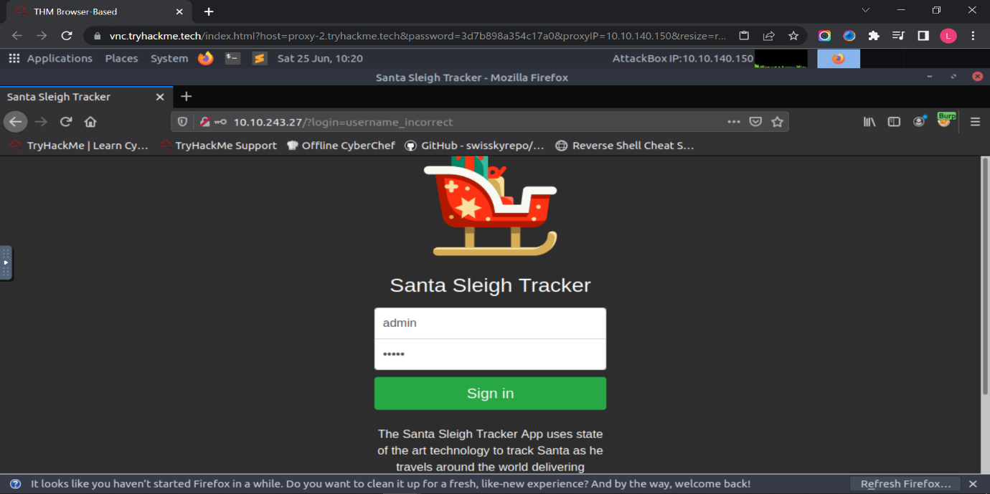

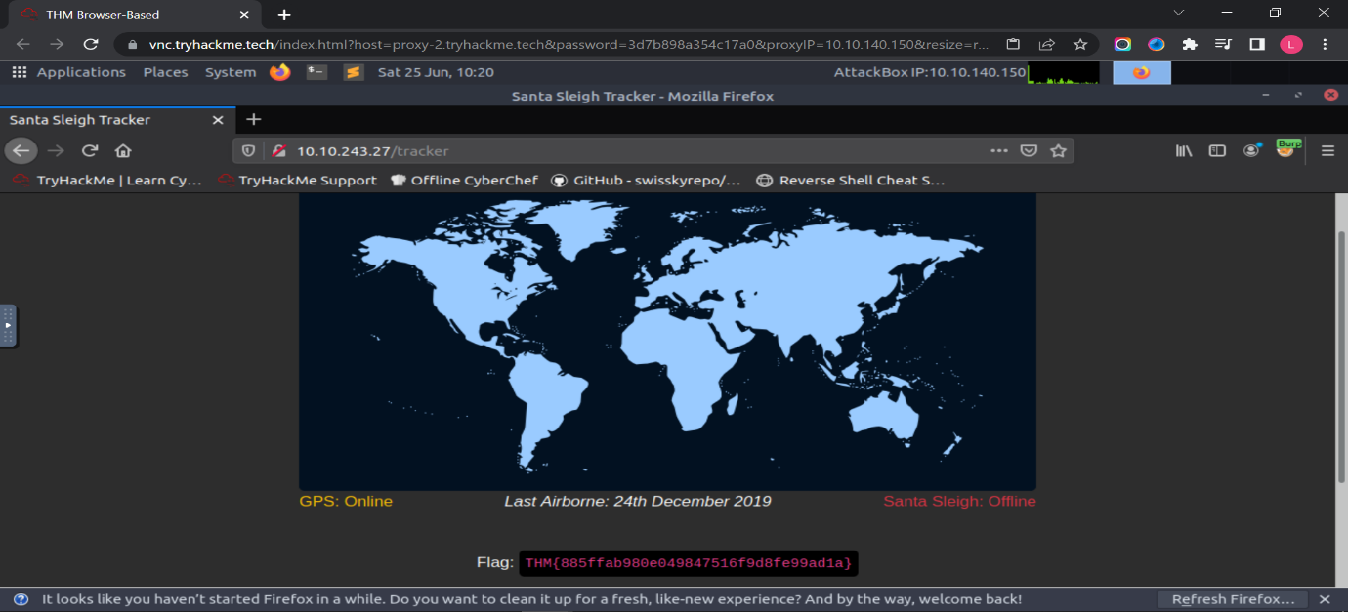

**Thought Process/Methodology:**

After paste the machines IP and access to the webpage, we click on the FoxyProxy browser extension, and select "Burp". Next, we go to the BurpSuite application and click the Proxy tab, then click the button "Intercept is on". We type the username and password. Next, we back to BurpSuite right click and click the “Send to Intruder” and click on the “Forward” button until nothing pops up. We click the "Positions" tab and clear the pre-selected positions. We add the username and password values as positions. Then, we select "Cluster Bomb" in the Attack type dropdown menu. We click the "Payloads" tab, select your Payload set. For set 1 (username), we will add a few common default username entries such as "admin", "root" and "user". For set 2 (password), we will add a few common default passwords such as "password", "admin" and "12345". Lastly, we click the "Start Attack" button, this will loop through each position list in every combination. You can sort by the "Length" or "Status" to identify a successful login. We go back to the webpage and type the successful login and get the flag.

**Day 4: Web Exploitation – Santa's watching**

**Tools used**: Kali Linux, Firefox, Terminal

**Solution/walkthrough**:

Question 1

According the sequence of the wfuzz command

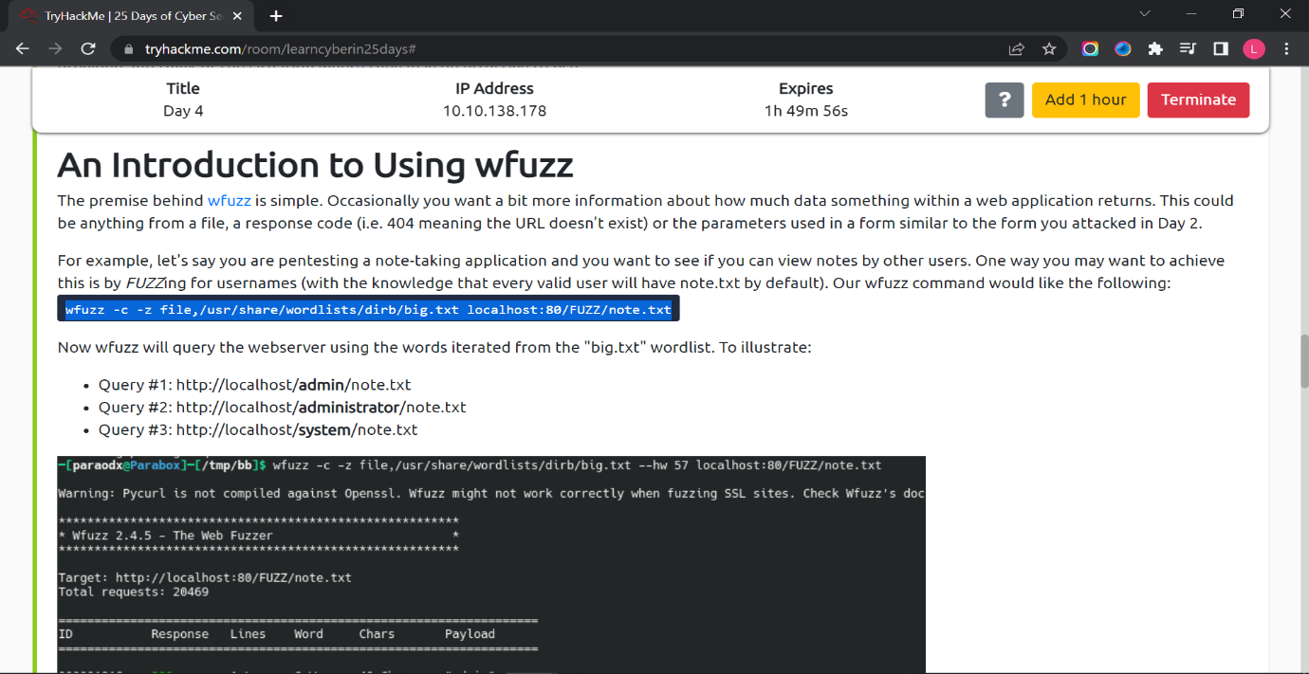

Question 2

Add “/api/” behind the IP address to find API directory.

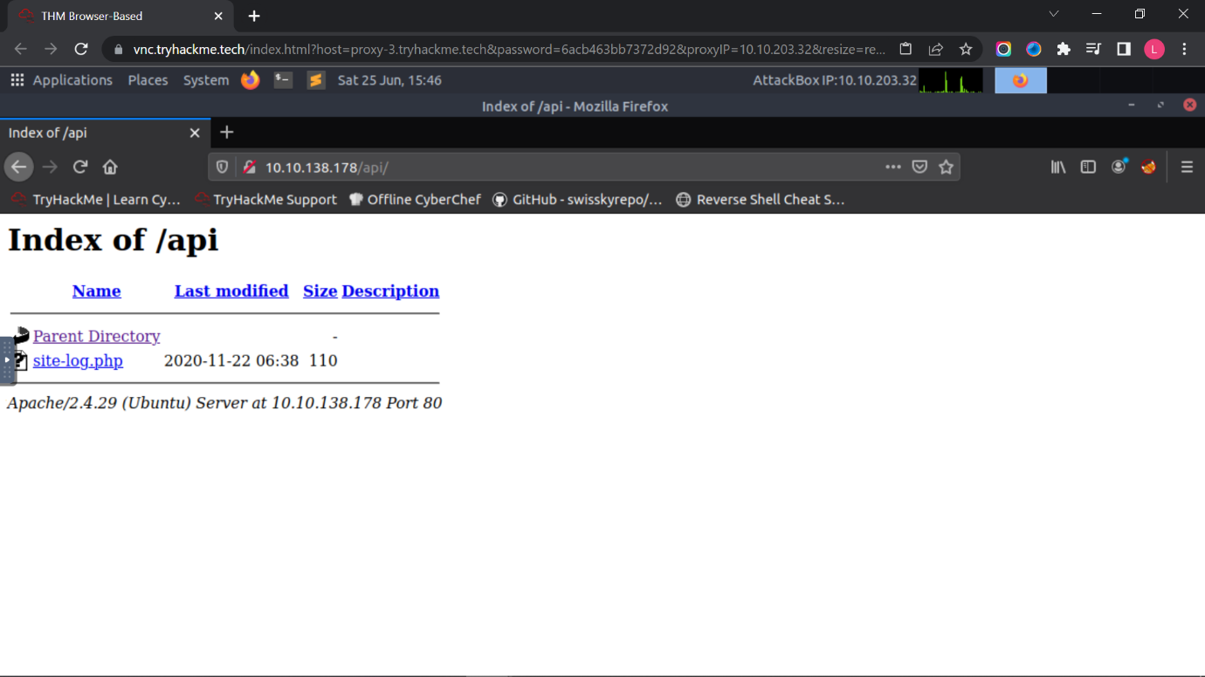

Question 3

Type “wfuzz -c -z file,/opt/AoC-2020/Day-4/wordlist -u http:// IP address/api/site-log.php?date=FUZZ” to terminal and find out the one that different with others.

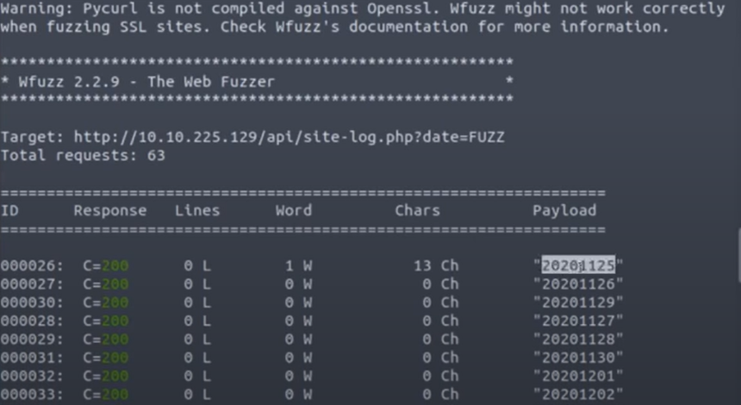

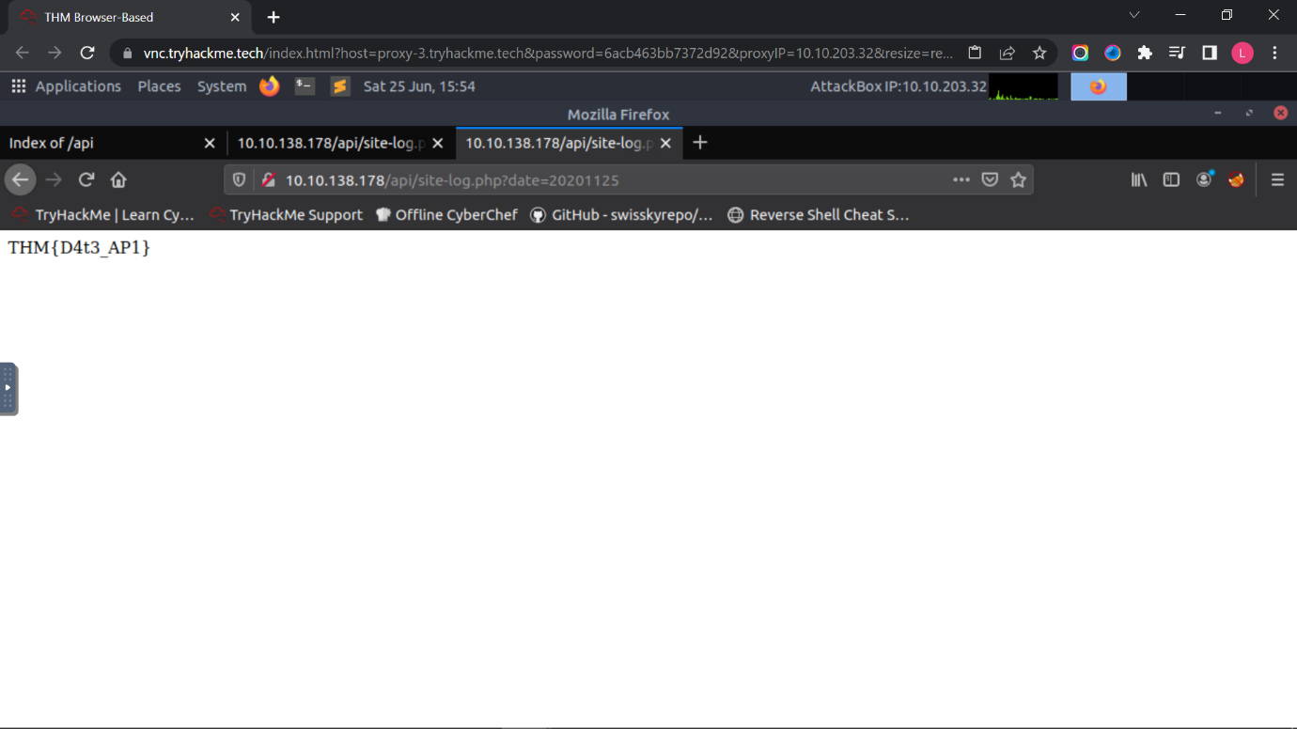

Question 4

The -f parameter store results to filename and printer.

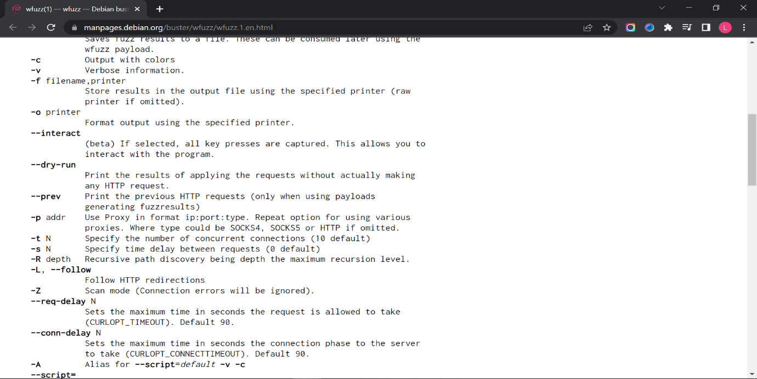

**Thought Process/Methodology:**

First, we type the IP address into the web browser. We type the “wfuzz -c -z file,/usr/share/wordlists/dirb/big.txt localhost:80/FUZZ/note.txt” in the terminal. Next, we back to web browser and add “/api/” at the back of the URL and we found the “site-log.php”. We type “wfuzz -c -z file,/opt/AoC-2020/Day-4/wordlist -u http:// IP address/api/site-log.php?date=FUZZ” to terminal and find out the one that different with others. Lastly, we add the date from the terminal and we get the flag.

**Day 5: Web Exploitation – Someone stole Santa's gift list!**

**Tools used**: Kali Linux, Firefox, BurpSuite

**Solution/walkthrough**:

Question 1

The default port number for SQL Server running on TCP is port 1433.

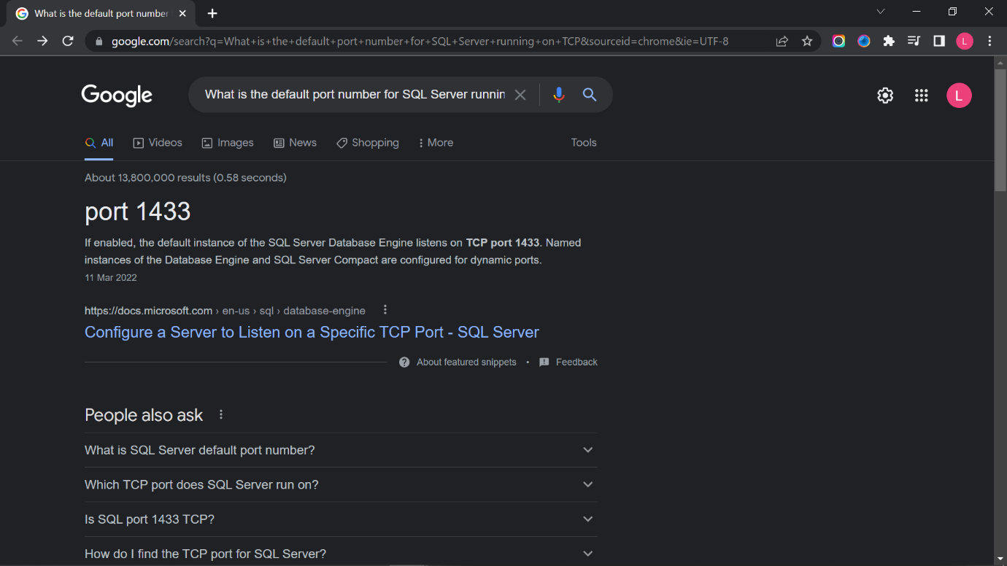

Question 2

The Santa's secret login panel is “/santapanel”.

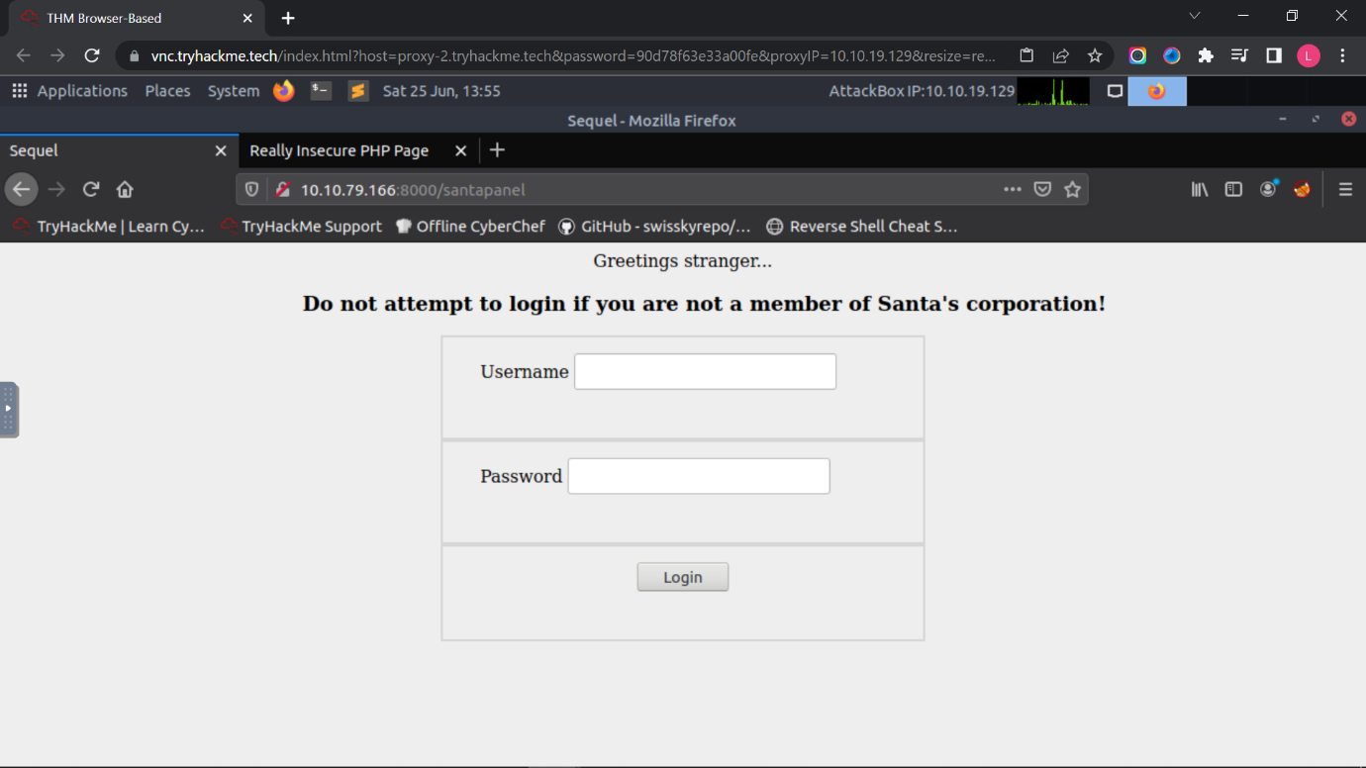

Question 3

The database used from the hint in Santa's TODO list is sqlite.

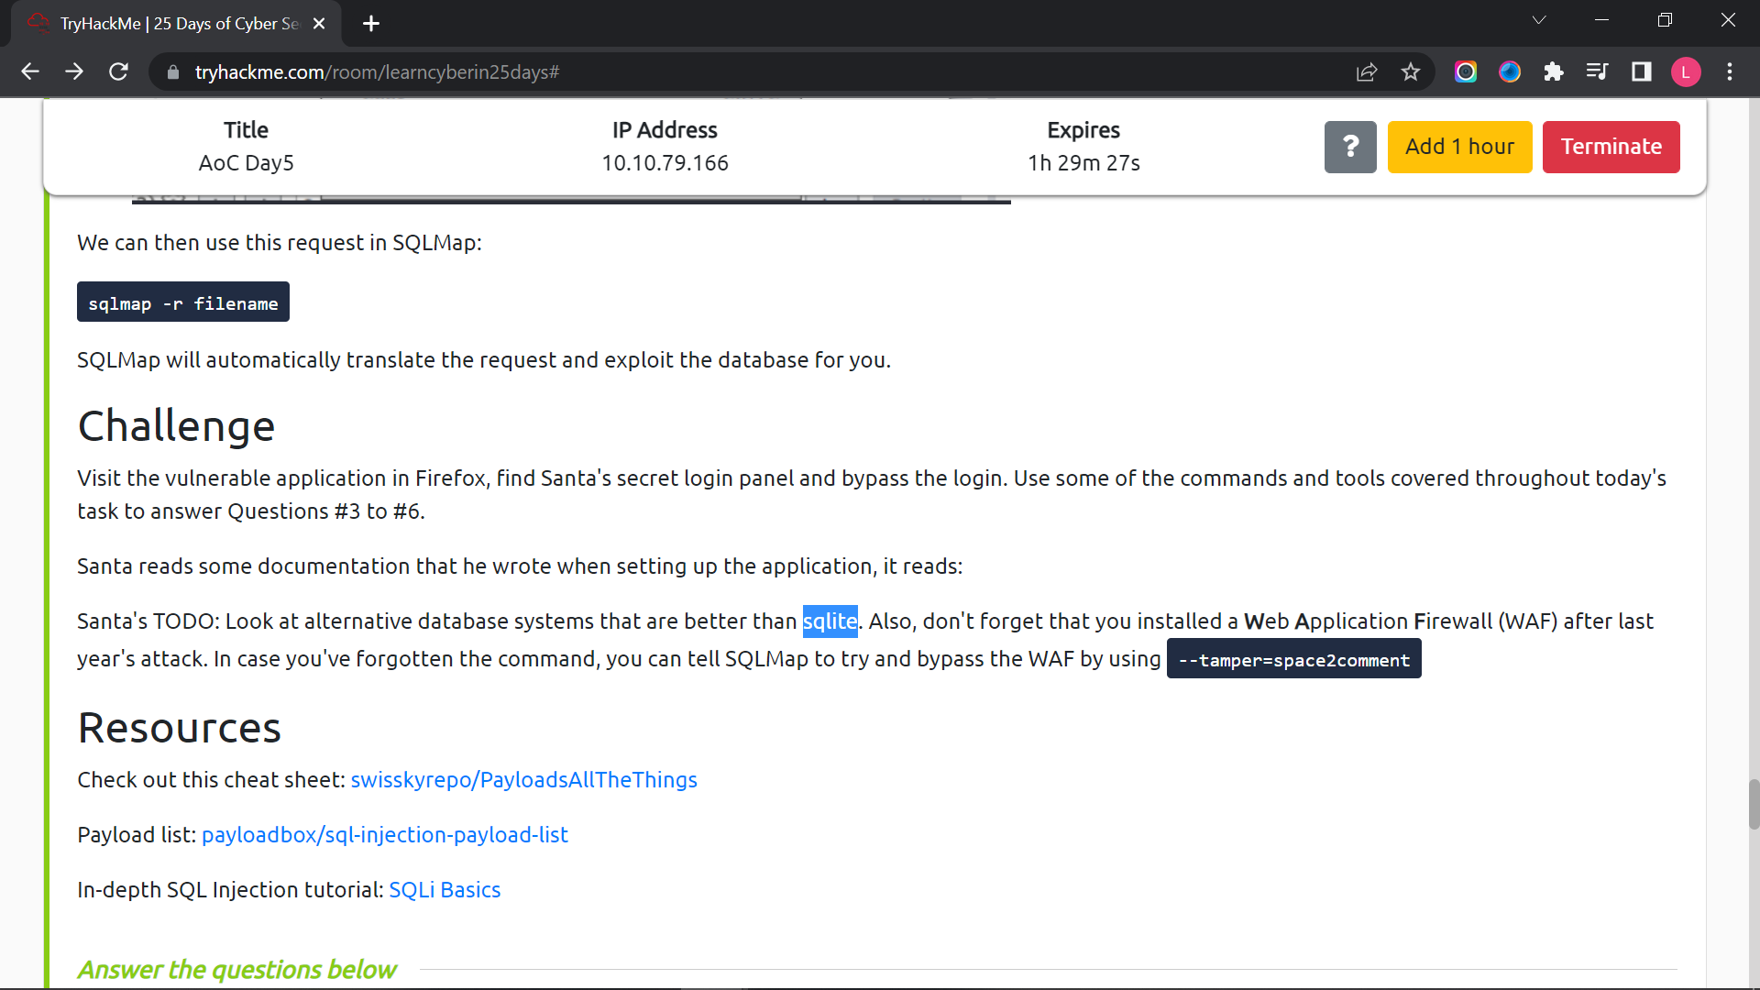

Question 4

There are 22 in the gift database.

Question 5

James’s age is 8.

Question 6

Paul ask for github ownership

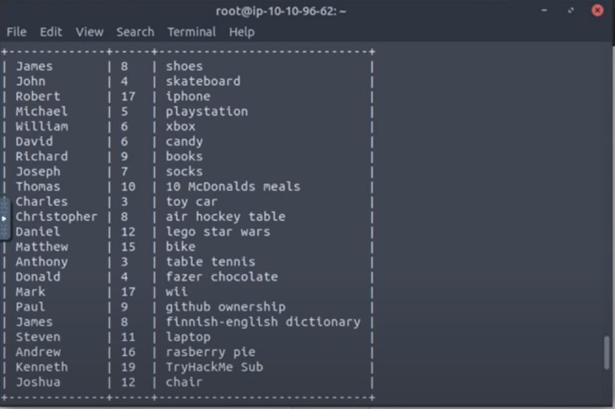

Question 7

Type “sqlmap -r panel.request --tamper=space2comment --dump-all --dbms sqlite” in terminal and scroll down find the flag.

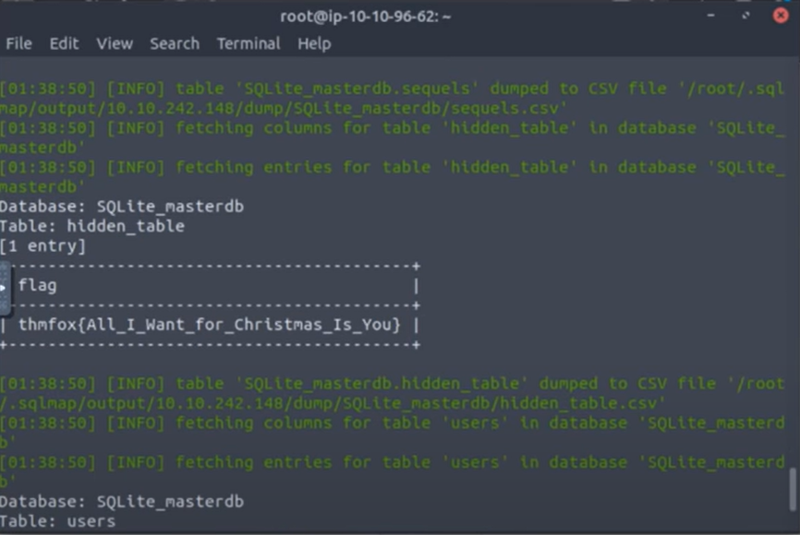

Question 8

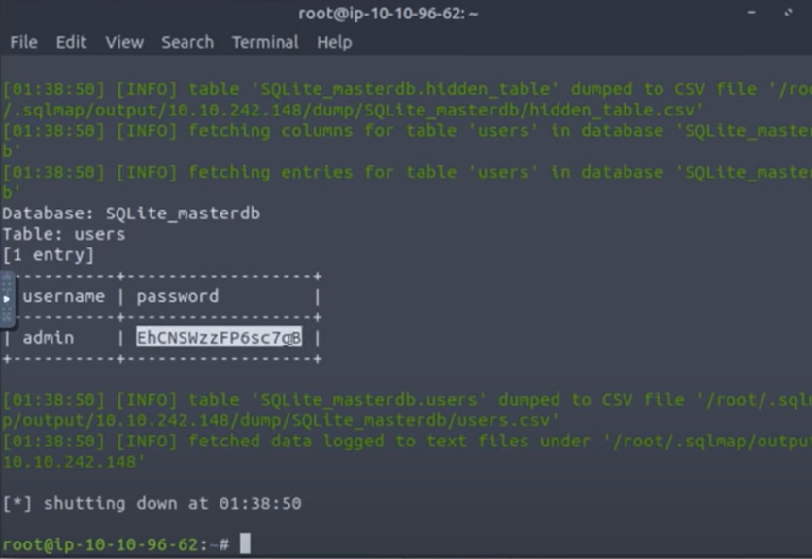

**Thought Process/Methodology:**

First, we type “IP address.8000/santapanel” into the browser search bar and access to the webpage. Next, we enable the FoxyProxy in firefox. We send the request from the "Proxy" tab to the repeater by right-clicking and pressing "Send to Repeater". We right click and click save item and name it as “panel.request”. We type “sqlmap -r panel.request --tamper=space2comment --dump-all --dbms sqlite” and it will get all the information and flag.